**Life Organiser**

**Overview**

Life Organiser is an application designed to assist people with scheduling their busy lives and allowing them space to reflect on what went well and what they could have done better. Users will create a profile which will be saved on a database. This profile will track their calendar and their to-do list. Users will fill in the days of the calendar with their tasks which will automatically get added to their to-do list. Once users mark a task as complete, they will also be able to journal how they feel the task or day went.

This will be programmed in Java. The IDE will be Injellij, the GUI will be made using Swing, the database will be built using SQLite for Java. Version control will be handled using Github.

**Requirements**

* Users must be able to create a profile
* Users must be able to access a calendar for any month of any year
* Users must be able to access an interactive to-do list
* Users must be able to journal regarding their days and their specific tasks

**Persona one: Student**

John is a student at Glasgow University and the workload is much higher than he anticipated. On top of that he has a part time job and has agreed to become treasurer for the Athletics society. On top of all that he doesn’t do well at remembering important dates like birthdays. Having all of the things he has to do in one list would help John keep on top of his life which is spiralling into disorganization.

**Persona two: Personal Trainer**

Jane is a personal trainer in Glasgow. Her personal touch has created positive word of mouth which has meant that she is blocked booked. With so many new faces each with their own unique issues Jane is struggling to remember how previous sessions went. By journaling how each session right after Jane can have a reliable account of the customer’s successes and failures and use these to keep up her personal touch as her business expands.

**GUI Map**

The user will start at the log in page from here they can log in to their account which will take them to their dashboard from the dashboard they can view their to-do list select any task to go to the task page as well as any calendar for any month of any year. From the dashboard they can also logout which will take them to the log in page. Alternatively, from the log in page they can choose to register a new account which will take them to the register new account page. They should be able to return to the log in page from the create new account page.

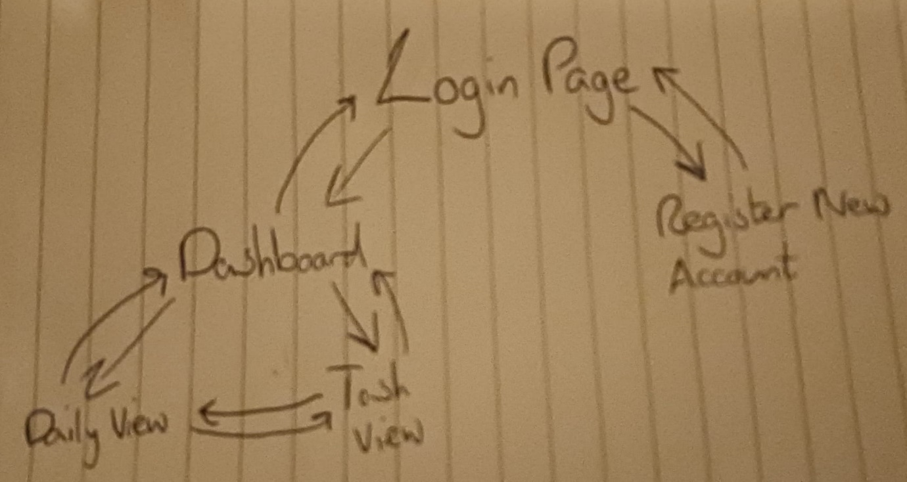

**Wireframes**

**Login page**

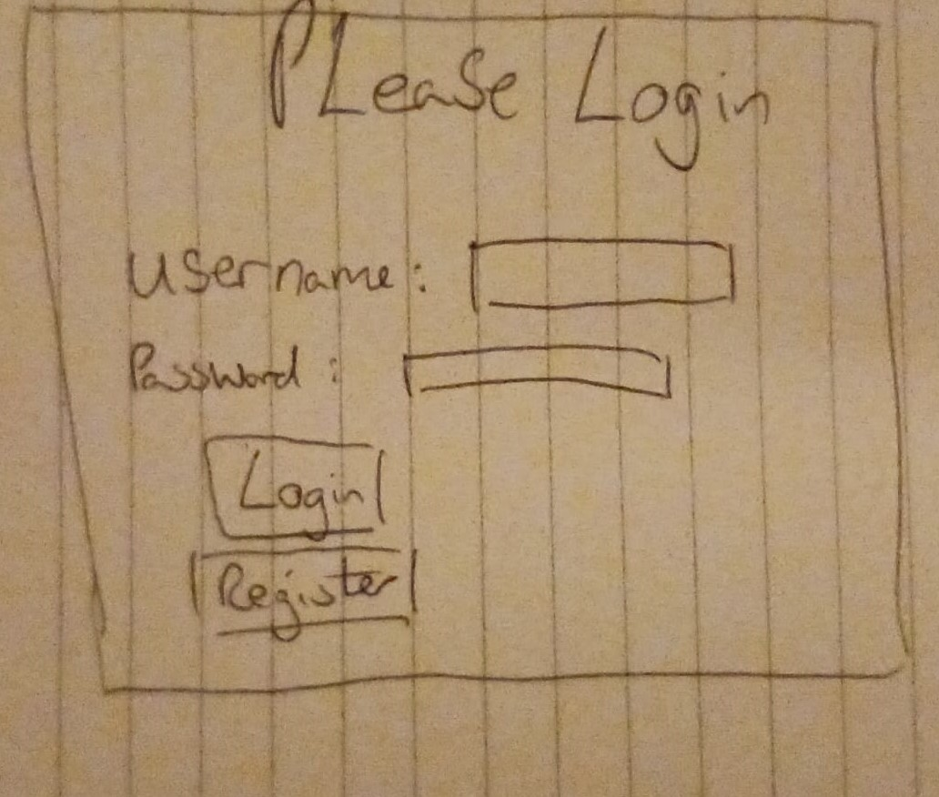

**Dashboard**

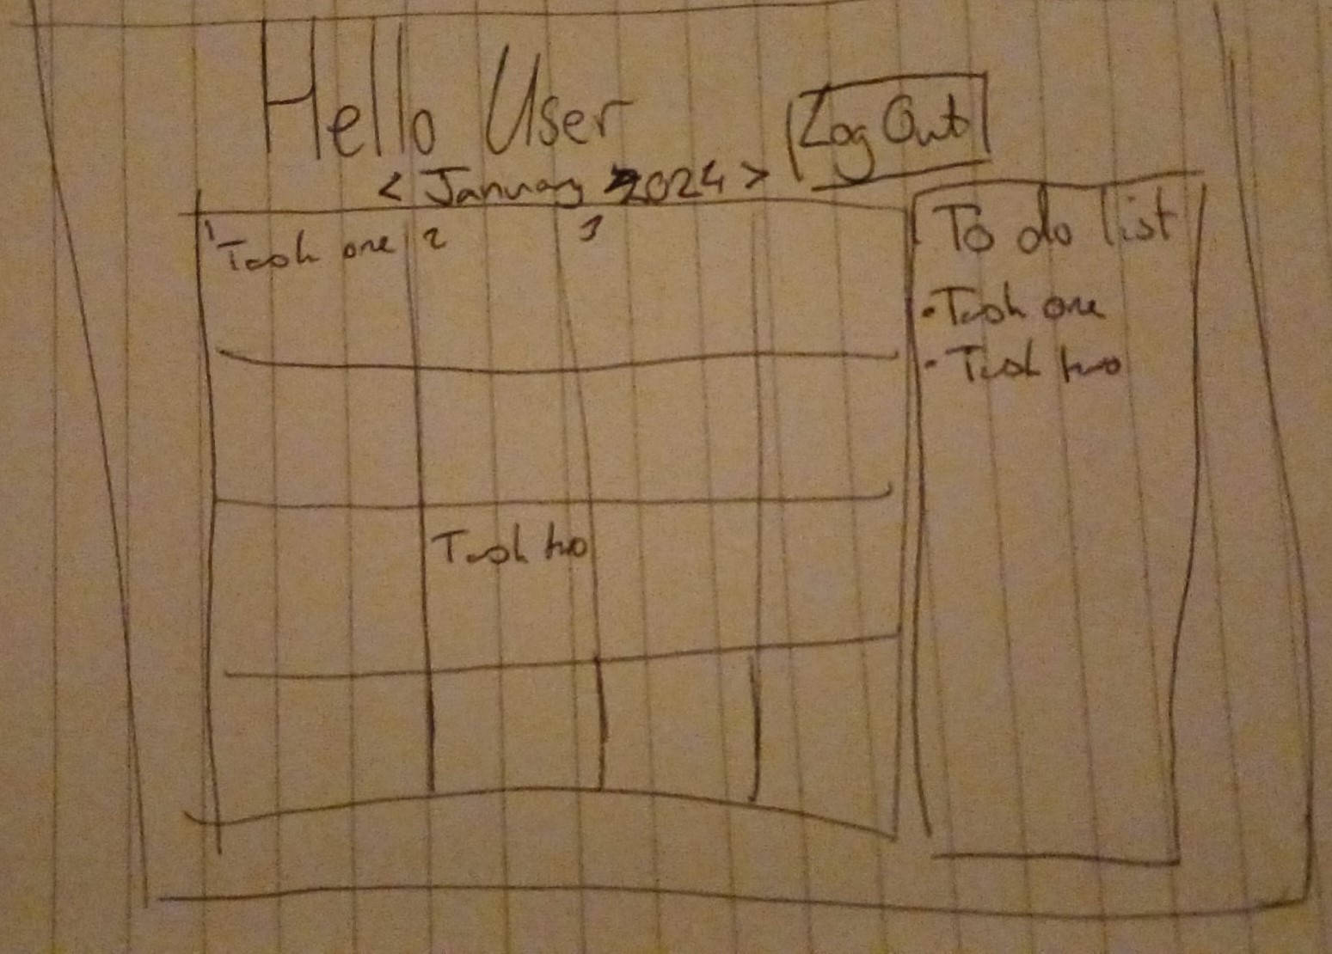

**Daily View**

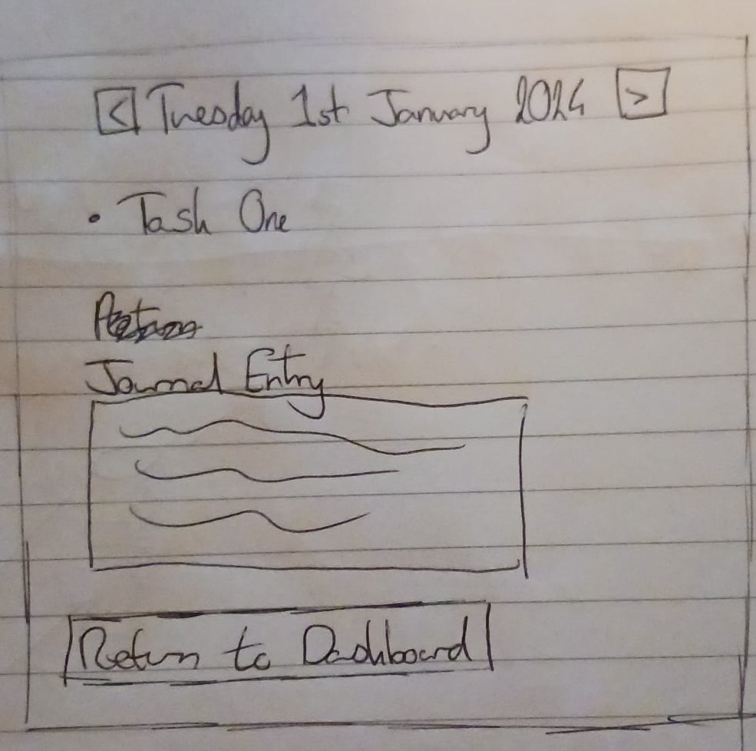

**Task View**

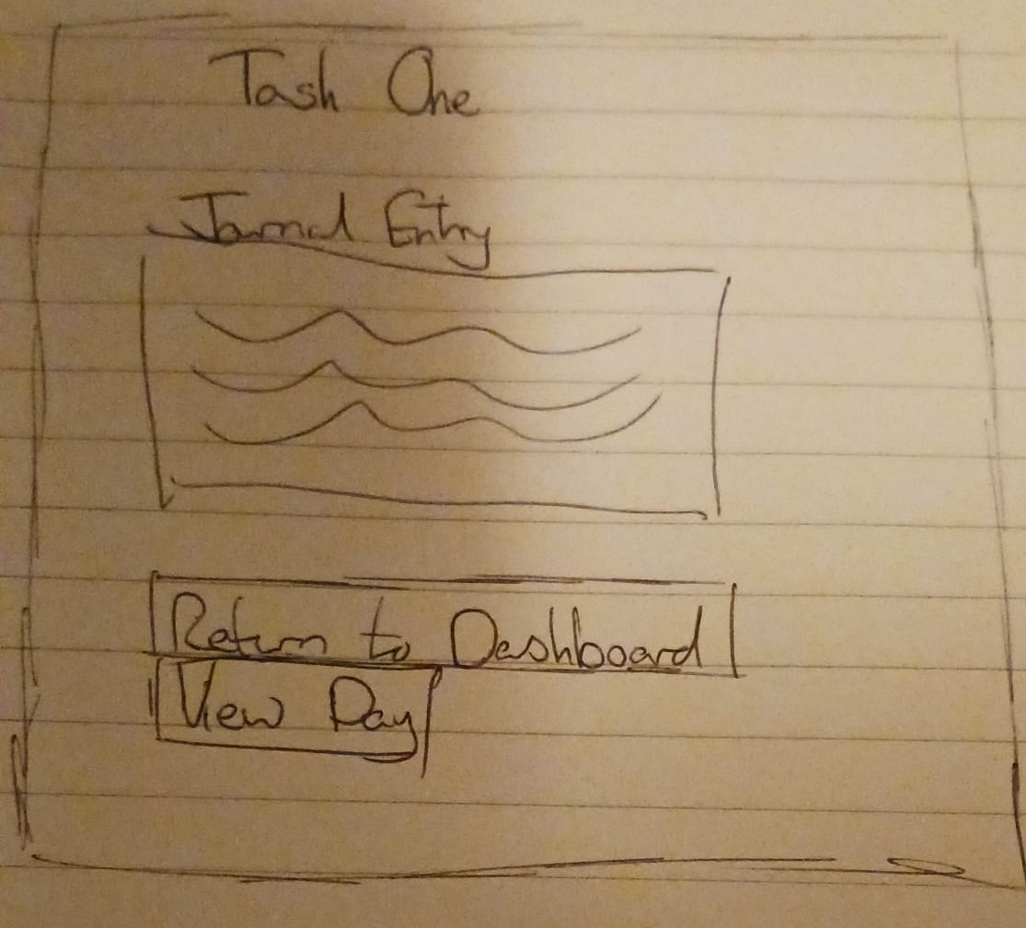

**Register New Account**

